School ICT policies

Slide 2:
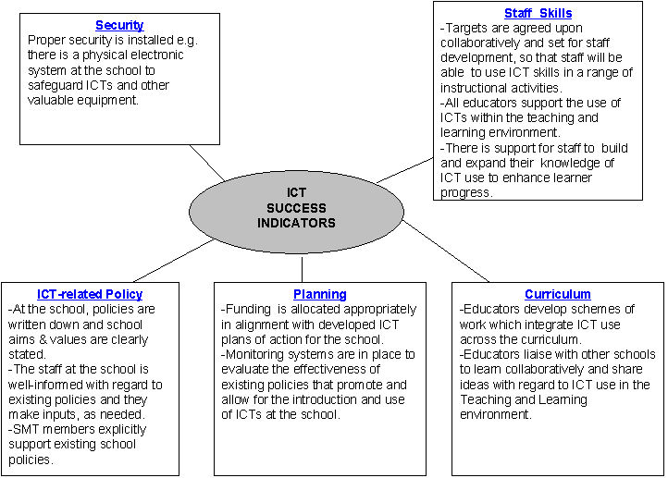

Slide 3:

Focus on ICT policies

Why are policies useful?

- Policies are documents that provide guidelines for action, and highlight the interventions that a school wants to take.
- These guidelines assist the school in its day-to-day practice.
- In order for policy to be meaningful it must be put into practice.
- Policy should guide the Governing Body, the School Management Team and the staff in dealing with problems that arise when guidelines are not followed.
- Once policies have been developed, adopted and communicated to the entire school community, they become firm and fixed guidelines for the day-to-day practices in the school.

Why should a school have an ICT policy?

More and more schools and educators are becoming convinced of the potential of Information and Communication Technologies for teaching and learning. However, schools should determine their plans for the inclusion of ICTs in the curriculum, as best suits their particular situation. Schools differ in size, layout and the technical expertise of the staff, so there is no one solution that schools can follow to ensure that maximum benefit from the use of computers can be derived. Schools have now become targets for the marketing of the latest hardware and software. It is important, therefore, that schools should decide how they wish to use the emerging technologies to best meet their needs.

In making these decisions about ICT, educational strategies should be at the forefront. This will determine the best use and configuration of the technology.

Why should a school have an ICT policy?

More and more schools and educators are becoming convinced of the potential of Information and Communication Technologies for teaching and learning. However, schools should determine their plans for the inclusion of ICTs in the curriculum, as best suits their particular situation. Schools differ in size, layout and the technical expertise of the staff, so there is no one solution that schools can follow to ensure that maximum benefit from the use of computers can be derived. Schools have now become targets for the marketing of the latest hardware and software. It is important, therefore, that schools should decide how they wish to use the emerging technologies to best meet their needs.

In making these decisions about ICT, educational strategies should be at the forefront. This will determine the best use and configuration of the technology.

Slide 4:

Who should be involved in putting the ICT policy together?

The entire staff, as well as, parents and management, should be involved in the creation of the school ICT policy. Some schools have found it useful as a starting point to use a questionnaire or to have a brainstorming session where educators are allowed to state what they feel the plan should include. An educator or principal can draw up a first draft of the policy. The policy is then circulated amongst all the stakeholders for comment or correction. The policy will evolve and require regular review and updating.

Slide 5:

What should the ICT policy include?

The ICT policy should include some or all of the following components, as deemed necessary by the school:

How can ICTs enhance teaching and learning?

Schools need to decide if / why ICTs are required in their particular school and to identify how they can impact on learners and educators. The potential as well as the limitations of the technology needs to be discussed and a consensus needs to be reached on the justification of spending scarce resources on hardware, software and peripherals.

Within the context of the overall school curricular plan, the computer could be looked at as a tool for motivating learners and allowing opportunities for collaborative and social learning. Many curriculum reinforcement packages allow for very specific individualized learning and the use of ICTs in remedial teaching or with learners of exceptional ability. This can be investigated. ICTs allow learners access to huge amounts of information through reference packages and the Internet and, in this context, the role of the educator as a “facilitator of learning” can be addressed. Adaptive technologies open up immense possibilities for learners with special needs and many schools may need to look at this area in their school plan.

Staff development

The importance of staff development cannot be underestimated. Although there may be existing expertise in the school, plans should be put in place to ensure that this expertise is shared and updated, that all educators are given a scheduled opportunity to learn and that training is a regular and ongoing process. The plan should state the budget for staff development procedures and should also state whether the staff development will involve the whole school, be in-house, classroom-based, or take place during or after school hours, such as during holiday time.

Workshop 2.1 in these Leadership resources focuses on staff development opportunities.

Control and monitoring

Both teachers and learners need access to technology if they are to benefit to the same extent as peers and colleagues in better-resourced schools. The scheduling of access, supervision and support of users are practical issues that need to be addressed.

Access to ICT also raises issues regarding ethical use of information and technology. Workshop 3.2 will touch on these issues.

Hardware upgrades

- How often?
- By whom?
- What budget is allocated for it

Software
Evaluation of new soft ware

- How often?
- Who evaluates?
- What criteria?

Back up of software and data and storage of all media and manuals
- Who does the back–up?
- How often is back–up needed?
- What type of back–up is best suited to the school needs?
- Where are back-ups stored?
- Who has access?

Responsibility for repairs

A proper plan should be put in place regarding computer repairs. This is because computer down time may take time to be sorted out.

Only properly trained computer technicians should be allowed to repair the computer.

It is therefore very important to budget for computer repairs in the initial budget.

Financial plan budget

The financial plan and the budget for the purchase of hardware, software and maintenance over a defined period of time (for example: 3 years in the medium term) should be documented. As existing hardware depreciates and edges towards obsolescence, it is worthwhile to consider whether the purchase of new or replacement hardware should be included in the budget. Many schools fall into the trap of over–allocating funds for hardware. The computer is only as good as the software it is running and the peripherals it operates.

Slide 6:

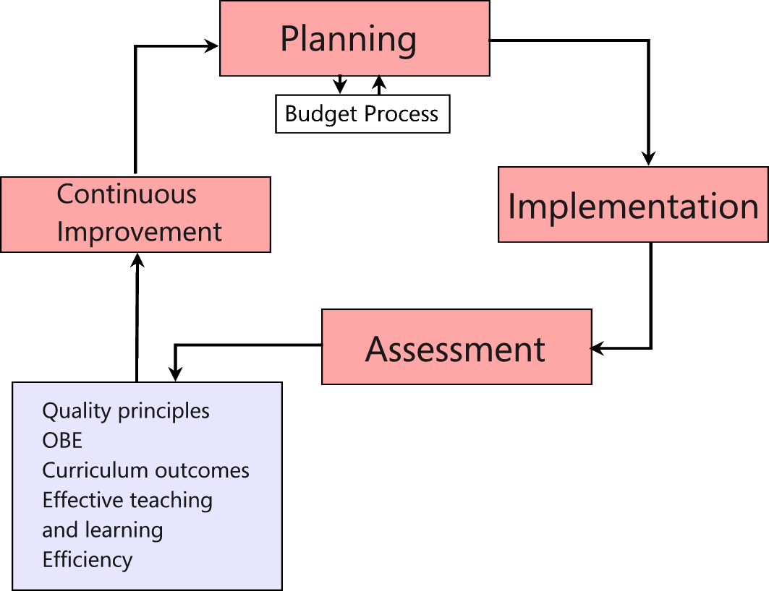

Slide 7:

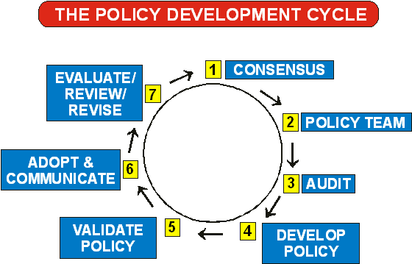

Slide 8:

Eight things to bear in mind when developing a policy

- Policy development is a very time-consuming task, so persevere!

- Some policies can be developed quickly because the issues are straightforward, while other policies may take a longer time to develop because more consultation is required.

- When doing research and gathering information, national and provincial acts and regulations must be considered as they set the parameters within which school communities can develop their own policies.

- When doing research, use examples of policies from others schools. Schools will be more than willing to help you with the process.

- The policy should also capture the interests of the school community.

- Ensure that the necessary resources are available to implement the policy.

Finally, remember that your school is unique and has its own unique needs, which your policies should reflect.

Four principles in drawing up policies
- Policies must be developed within the National and Provincial regulatory framework.
- SA Schools Act (1996) stipulates a number of important principles in drawing up policies, namely that they must be consultative and promote participation, transparency, accountability and fairness. Details are as follows:

Consultative: While members of the School Governing Body (SGB) and the School Management Team (SMT) lead the process in developing policies, these policies can be finalised only after consultation with the entire school community. It is very important for the School Management Team, Governing Body and school community to work together in sharing their ideas and expertise. Members of the SMT, however, do have an intimate and well-informed understanding of the day-to-day running of the school and should be trusted to lead the process.

Accountability: It is essential that policies promote accountability. When implementing policy, the Governing Body, as well as the SMT, should be accountable for the actions they take and be prepared to communicate reasons for their actions to the school community.

Transparency: Polices should be clear and transparent without hidden agendas. All members of the school community should clearly and easily understand them.

Fairness: Policies must be fairly and consistently applied to all concerned. There should be no favouritism.

When developing policy, those responsible should be clear about the aspects of school life the policy will address, as well as the possible consequences of transgressing the policy guidelines.

