Project 3
Investigating Careers
Module
2
student Lesson
Module 2 introduces you to the concept of job clusters – the general job categories that are useful for job-seekers. Then, you will complete two career investigations. The first will be a general overview, and the second will be an in-depth study. You will match possible major fields of study (for your chosen career) with educational institutions that will support the educational training required. Finally, you will input your jobs data into a Microsoft Access database, and use its sorting capability.
Job Categories or Clusters
In order to make the enormous task of career exploration more manageable, it’s important to think of over-all employment opportunities as jobs that fall into general ‘clusters’ or categories. A ‘cluster’ can be defined as a group of occupations related to a particular industry or field. Whenever a job-seeker searches for employment, they have to narrow down the search by selecting an area, ‘cluster,’ or sub-category of similar skills, educational background, and responsibilities. Usually, there are about two dozen clusters that are commonly provided on job-search sites.
Exercise 2.1: Choosing the Fifteen Most Common Job Clusters
Explore the recommended websites listed below and select what you believe is the best grouping of 15 job clusters. You will find that you may need to reword the title for each ‘cluster’ category. You will complete this task in teams.
Indiana Career Postsecondary Advancement Center: Career Clusters
http://icpac.indiana.edu/careers/clusters/index.xml
Provides 14 groups of related occupations. (Click on “Non-Indiana User” when prompted.)

Jobs Listed by Occupational Field
http://www.careers.org/topic/01_jobs_70.html
A list of job resources on the web organized by occupational field.
Career Briefs
http://www.soicc.state.nc.us/soicc/info/briefs.htm
Provides 18 types of career categories in an index.

Job Listings: The Riley Guide
http://www.rileyguide.com/jobs.html
Scroll down to see various categories of jobs, beginning with “Engineering, Science, and Manufacturing.”

O*NET Online: Find Occupations
http://online.onetcenter.org/gen_search_page
Use the drop-down menu to access job categories.

Career-Explorer: Find a Job
http://www.bestjobsusa.com/~specials/partners/careerex/
Again, use the drop-down menu to access job categories.
In the chart below, list your group’s choice of job categories or clusters.
List of 15 Clusters, Groups or Categories
1
2
3
4
5
6
7
8
9
10
11
12
13
14
15

Share your group’s list with the rest of the class. The entire class must reach a consensus (agreement) on the fifteen job categories that you will be using in a jobs-bank database.
Exercise 2.2: Matching Job Clusters
Identify which of the 15 previously-decided general cluster areas or job categories match each of your specific recommended jobs (from Exercise 1.3).

Six Selected Jobs  (from the recommendations  in Exercise 1.3) |  | Cluster Group Identification

1.

2.

3.

4.

5.

6.

Exercise 2.3: Careers Exploration – General Overview
Briefly gather information about the six careers that were recommended and based upon the results of your online career assessment (in Exercise 1.3). You will be obtaining details about your six recommended jobs, including job description, education required, and salary range (average annual). A sample is provided below.

Exercise 2.3: Six Career Possibilities
Job Title: Loan Officer
Brief Description: Evaluate the credit of an individual or business applying for a loan; authorize loans or advise borrowers.
Education Required: Two years, community college minimum; normally a Bachelor’s Degree required
Average Annual Salary Range: $27,660 to $48,000
1. Job Title:
Brief Description:
Education Required:
Average Annual Salary Range:
2. Job Title:
Brief Description:
Education Required:
Average Annual Salary Range:
3. Job Title:
Brief Description:
Education Required:
Average Annual Salary Range:
4. Job Title:
Brief Description:
Education Required:
Average Annual Salary Range:
5. Job Title:
Brief Description:
Education Required:
Average Annual Salary Range:
6. Job Title:
Brief Description:
Education Required:
Average Annual Salary Range:

Below are recommended website resource links that will assist you in obtaining summary information about each of the six careers that you will be describing in your chart. Your teacher may suggest other sites as well. Use more than one of the following website resources in order to complete this exercise:
US Department of Labor: Occupational Outlook Handbook
http://www.bls.gov/oco/
Provides information on hundreds of jobs.
The Princeton Review: Find Careers and Internships
http://www.princetonreview.com/cte/search/careerSearch.asp
Search for descriptions of different careers and available internships.
ICPAC: Career Profiles Index
http://icpac.indiana.edu/careers/career_profiles/
Provides profiles for 480 different careers. (If necessary, click on non-Indiana user).
Career Briefs
http://www.soicc.state.nc.us/soicc/info/briefs.htm
Provides summary information on hundreds of career choices. Careers are grouped by clusters.
CareerMatters: All Careers
http://www.ilc.org/cfmx/CM/Careers/cm_career_list.cfm
Provides an alphabetical listing of hundreds of possible job-careers, from the Independent Learning Centre in Ontario, Canada.
O*NET Online
http://online.onetcenter.org/gen_search_page
Search information on hundreds of jobs.
Monster.com: Job Profiles
http://jobprofiles.monster.com/
Contains interesting and colorful descriptions for 120 different kinds of jobs.

Career-Explorer: Find a Job
http://www.careerexplorer.net/careers.asp
Click on the job categories to obtain summary information on a career.
In-depth Career Research
Exercise 2.4: Researching a Career
You will research, in-depth, one of the six careers (of your own choosing). You will complete the following ‘fields’ of information for your job selection, using Microsoft Word:
RIASEC Code:
Job Cluster or Category:
Job Title:
Job Summary:
Education/Training Requirements:
Skills Needed:
Average Annual Salary:
Future Outlook:
Related Job Titles:

Use the web sites listed in Exercise 2.1 to assist you in researching information on your career choice. The sites below may also be of assistance in your research:
Jobs and Careers Web Directory
http://www.careers.org/
Career Journal by Wall Street Journal
http://www.careerjournal.com/
Connexions: Career Database
http://www.connexions-direct.com/careersDatabase.cfm
A British website, with a series of drop-down menus that step-by-step narrows down career information, and provides a short description.
Career Voyages
http://www.careervoyages.gov/
Career InfoNet
http://www.acinet.org/acinet/
Career Preparation and Training
Anywhere in the world, employers are looking for the same kinds of things from applicants: the skills, background, and ability to do the job. As you look ahead, another concern is how to properly prepare educationally for a specific job interest. For example, a budding archaeologist may wish to know more about courses, major areas of study, level of education, types of degree programs, and training requirements that would be necessary to prepare for a career in that field. Likewise, a current interest in being a physical education coach prompts the question: what do I need to know now to help me become a better informed and educated person as I seek a rewarding career in coaching?
Exercise 2.5: Researching Educational Training to Support a Specific Career Interest
Use the suggested web sites below to match possible majors with educational institutions that will support the educational training required to pursue your specific career interest.
Indiana Career Postsecondary Advancement Center: Search National Schools by Major
http://icpac.indiana.edu/education/college_profiles/MajorsSearch.cgi
Click “Non-Indiana User,” then use the list of specific majors provided to search for degree programs offered by various schools.
The Princeton Review: Find Careers and Internships
http://www.princetonreview.com/cte/search/careerSearch.asp
Use the alphabetic menu provided to select a career or internship, and read about what a particular job would be like. Then click the Majors tab to see a list of suggested college majors that would be required for that chosen occupation. To investigate further, click on one of the items in the list of college majors, and then click on the “Schools Offering the Major” tab to see a list of matching schools.
Career-Explorer: Find a Job
http://careerexplorer.net/
Use the drop-down menu below the map to select a career category, then click the “GO” button. A list of educational institutions that offer training for the career choice will appear.
Worktrain.com
http://www.worktrain.gov.uk/Script/trainingsubjectareas3_0.asp?
A British site for National Jobs and Learning, with helpful information about training required for various jobs.
JobFutures.ca
http://jobfutures.ca/fos/browse-programs-education_level.shtml
Browse programs of study (or clusters) by educational levels: trade/vocational, community college, undergraduate, and master’s university level.

Career Interest:
Suggested Majors | Recommended Educational Institutions
A Short Introduction to Career Databases
Essentially, a database is a collection of data arranged for ease and speed of search and retrieval. One of the more useful desktop application tools for collecting, categorizing, and sorting data is a database program called Microsoft Access.
Exercise 2.6: Entering Information Into a Jobs Database
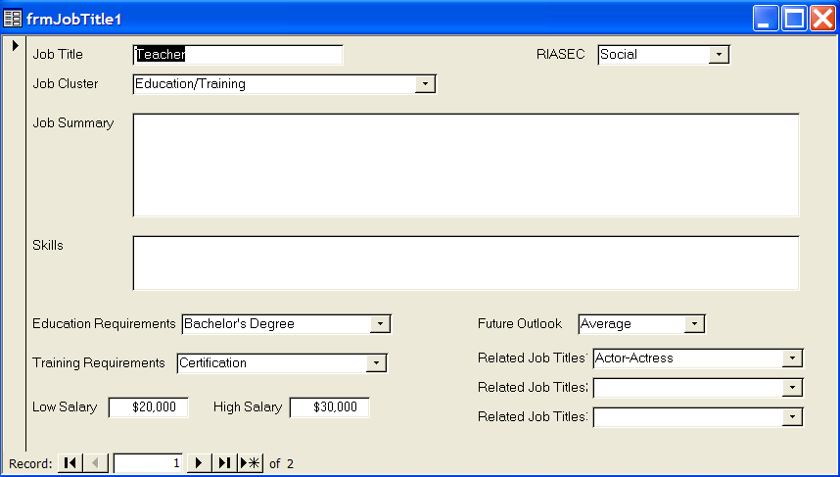
The valuable results of your in-depth career research will be collected, categorized and sorted within a database program, Microsoft Access. As a class you must decide on the format of the way to input data into each record to make the sorting process easier and more effective. The Step-by-Step Microsoft Access XP: Data Entry and Sorting guide provides instructions for helping you input your data. Below is a sample of the Careers Access database form:
Exercise 2.7: Sorting Information in a Jobs Database
Once all of your classmates have finished entering the career research into the class job database, you will learn how to sort and create reports. The Step-by-Step Microsoft Access XP: Data Entry and Sorting guide provides instructions on conducting database sorts and creating reports.

