Microsoft Word 2016

Picture layout




Scroll down or use the Page Down key to navigate this document.

1.1
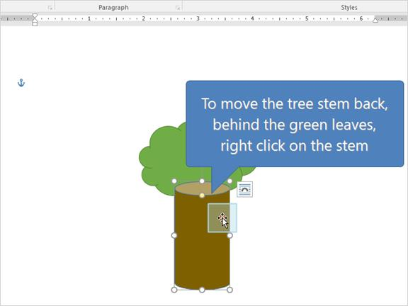

1.2
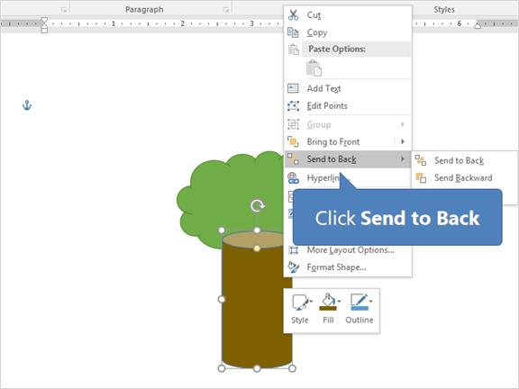

1.3
