Microsoft Pan African Innovative Teachers Forum 2008
The first Microsoft Pan African Innovative Teachers Forum was held in Accra, Ghana from 26 – 28 May 2008. This event bought together 37 teachers who are doing exciting projects using technology in their classrooms. These teachers represented 13 different African countries, namely: Burkina Faso, Gabon, Ghana, Kenya, Madagascar, Mauritius, Mozambique, Namibia, Nigeria, Senegal, Seychelles, South Africa and Uganda. Below is a report on the highlights of this two day long event.
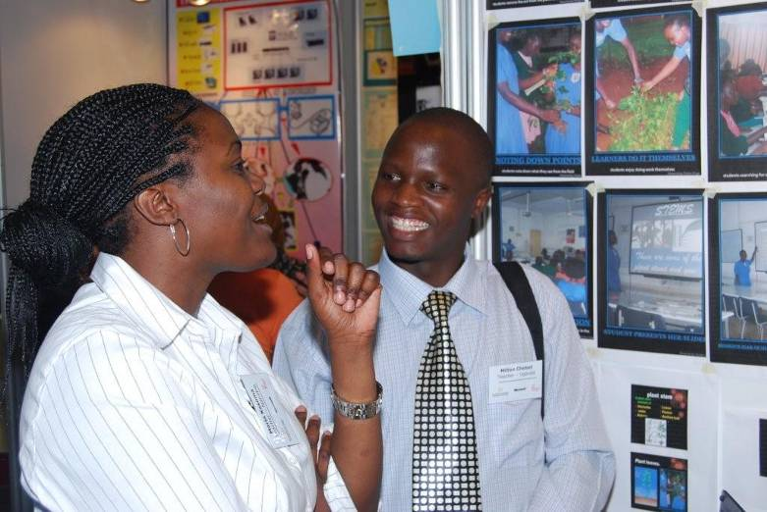
Networking
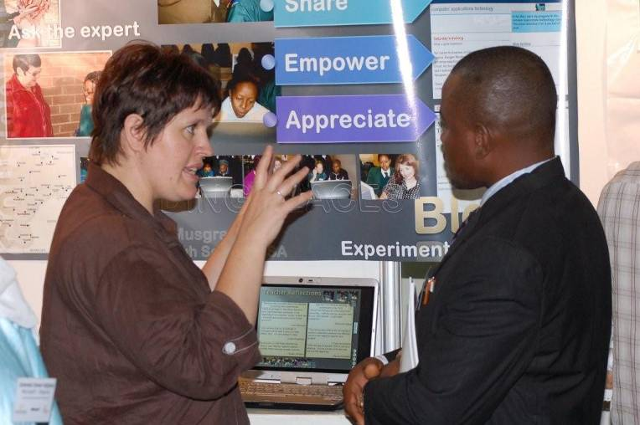
The aim of the Forum is to provide teachers with an opportunity to network and share ideas and also to allow them to make friends with colleagues in other countries who they can collaborate with on future projects. One of the requirements of the event was for each teacher to produce a poster showcasing his or her project. Time was then allocated for teachers to view one another’s displays and learn more about the projects.
For many teachers, this was a highlight of the event as is shown by the following comments:
“The conference has been impressive and more beneficial, giving me the opportunity to meet colleagues from other African countries to share ideas”

“I found the coming together of different nationalities in one forum, (with) us all being teachers, to be a very enriching experience”

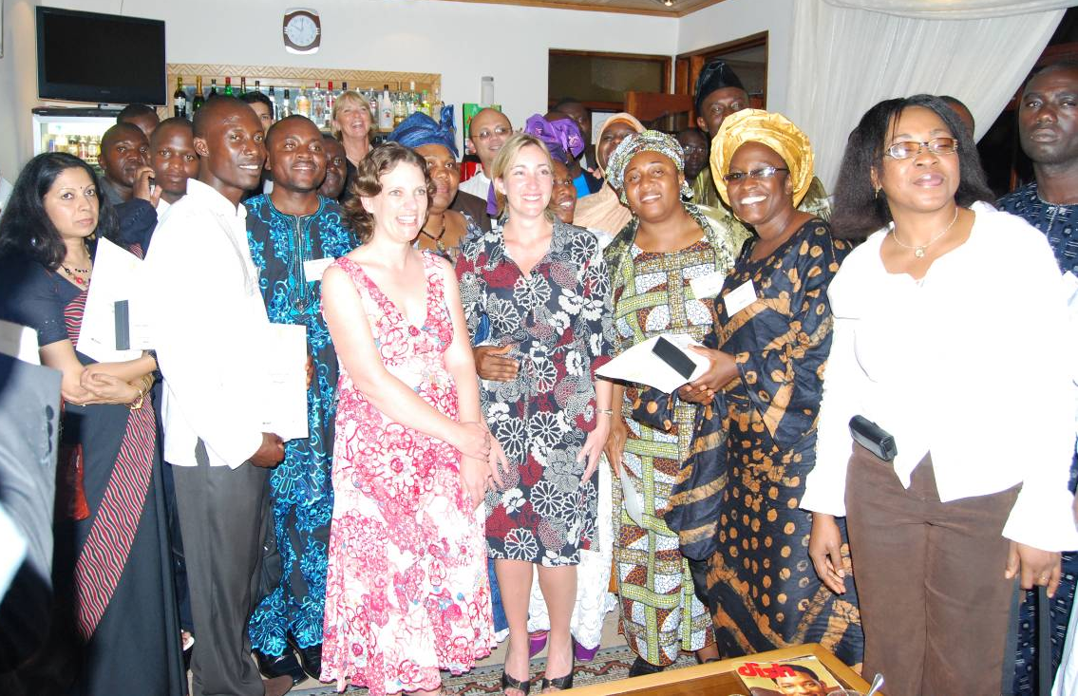
Awards
The Innovative Teachers Awards recognise teachers whose lessons and projects show exceptional innovation in terms of collaborating with others, producing content or making an impact on the community. The competition required teachers to submit a Virtual Classroom Tour (VCT) describing their lessons prior to the competition. These VCTs were then judged by a panel of judges who met at the Forum to discuss the entries and determine the winners.
One of the highlights of the Forum was the Gala Dinner held at Mahogany Lodge. During this event, digital cameras were awarded to the winners in each category by Alan Yates the Microsoft Worldwide Industry General Manager for Education. Each of these winners will also have the opportunity to present their projects at the Worldwide Innovative Teachers Forum which is to be held in Bangkok, Thailand in November, 2008.
The winner in each of the categories is listed below, along with a description of his or her project.
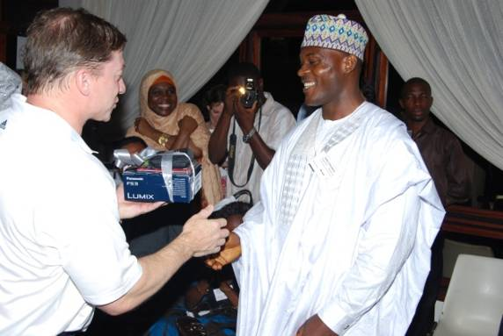
Innovation in Collaboration
Iyke Chukwu of Government Science & Technical College in Garki, Nigeria won this award for his project on Diverse Cultures. This Social Studies project for 14 – 15 year olds aimed to help students gain a better understanding of some Nigerian cultural practices and foreign culture. The teacher who produced this project is a computer studies teacher, but he realised that ICT resources could enhance this lesson and that the topic lent itself well to a collaborative project. The students worked in groups to research Nigerian history and culture using the internet, library and questionnaires. They also gathered materials and put on an open day exhibition. The project culminated in a visit to Hull, England to meet with the other schools to exchange ideas and experiences with the teachers and students. The partner schools consisted of three schools from the UK, three from Kenya and the other two schools from Nigeria. Next year the six partner schools from the UK and Nigeria will visit Kenya.
Alan Yates and Iyke Chukwu
Innovation in Community
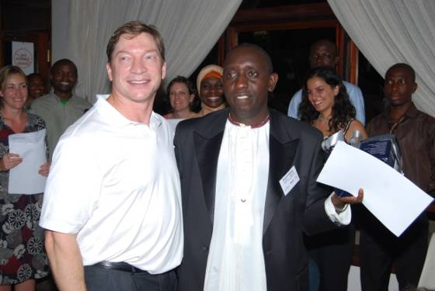
Ronald Ddungu of Gayaza High School in Uganda won this award for his project on Education for Sustainability. This project was conducted with 13 – 19 year old Mathematics and Physics students. The project had three components: Community Out Reach in which senior students were required to teach mathematics to students in a nearby primary school using ICT to prepare the resources; Building Networks in which students were required to organize an online seminar that had a one day face to face session; and finally Environmental Education in which several groups developed and tested lessons in Mathematics and Physics using trees.
Alan Yates and Ronald Ddungu
Innovation in Content
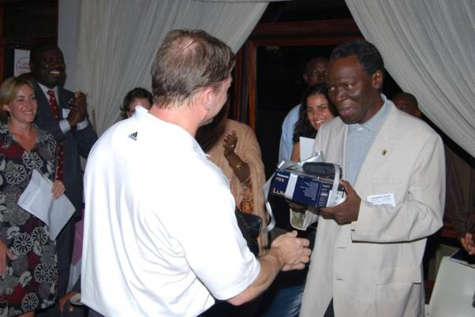
Ousmane Diouf of CEM Diery Fall in Senegal received this award for his Electronic Alarm Systems project. This Physics lesson for 15 – 20 year olds demonstrated how to use recycled electronic components to create a prototype of an alarm system. In the project, students used the internet to acquire basic knowledge of electronic components then they planned their alarm systems and purchased second hand components from a flea market. ICT use included creating PowerPoint screen files, comparing test results of the components and documenting the project by taking photos.
Alan Yates and Ousmane Diouf
Peer Review Award
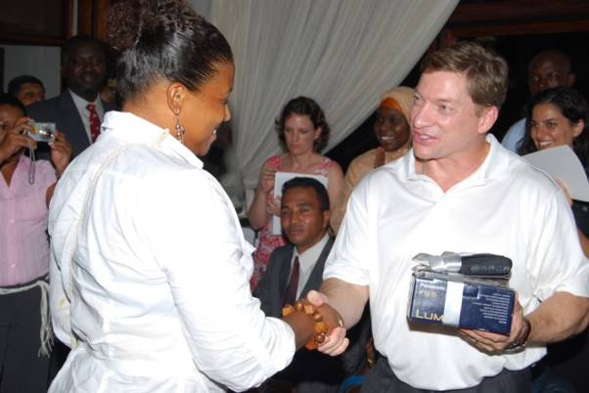
In addition to the awards that were determined by the panel of judges, a Peer Review Award was also awarded to the teacher voted for as the “most innovative” by his or her peers. This accolade was awarded to Marie-May Iman of Plaisance Secondary School in Seychelles for her “Tracking Sea Turtles” project.
Marie May Iman and Alan Yates
This Environmental Education lesson for 12 – 15 year olds involved students tracking a locally tagged sea turtle named Carol on an internet site and recording data on a graph or plotting tracked information using a map. Though tracking and monitoring the turtle students learnt about turtle characteristics, behavior and movement in a fun and exciting way. The students also worked in groups to research and gather information about sea turtles, edit the information and made a presentation using PowerPoint and Movie Maker.
The following teachers were awarded Highly Commended certificates for their outstanding projects:
Innovation in Collaboration
Victor Ngobeni – South Africa – Bright Lights or Dust Bowl (runner up)
Rosalind Denys – Seychelles – Creating Websites for School Communication
Sitabai Ramlugun – Mauritius – ICT Within and Beyond the School
Atim Uwah – Nigeria – Celebrations and Mourning
Innovation in Community
Sarietjie Musgrave – South Africa – Sharing Computer Knowledge with the Community (runner up)
Marie-France Barra – Seychelles – Upgrading or Creating Computer Systems
Marie-May Iman – Seychelles – Tracking Sea Turtles
Charles Yakani – Uganda – Energy and its Sources VLE
Innovation in Content
Sitabai Ramlugun – Mauritius – ICT Within and Beyond the School (runner up)
Illiyasu Adamu – Nigeria – Researching ECOWAS
Matthew Adjei – Ghana – Annanse makes a farm
Workshops and Presentations
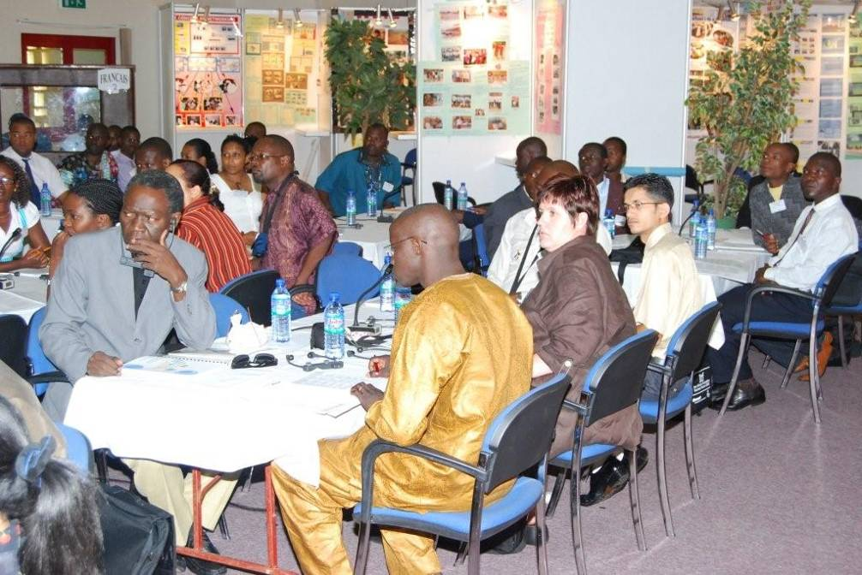
A further aim of the Forum was to expose teachers to new ideas, technologies and projects which they may be able to use in their classrooms. A series of workshops were presented with this aim in mind.
Mitch Benson’s presentation on “Microsoft Education Solutions” showed teachers some exciting tools that are still under construction but which they can look forward to using soon. Teresa Canady and Francine Fisher’s session on “E-Learning – Innovative usage through the MSITA Programme” allowed teachers to find out what options they have for getting themselves and their students certified at different levels.
James Sankale’s session on the “Role of mobile technologies in youth empowerment” proved to be popular as it gave innovative ideas for using mobile phones. Amr Hamdy’s presentation on the Mtandao Afrika competition exposed teachers to a web design competition which their learners can enter.
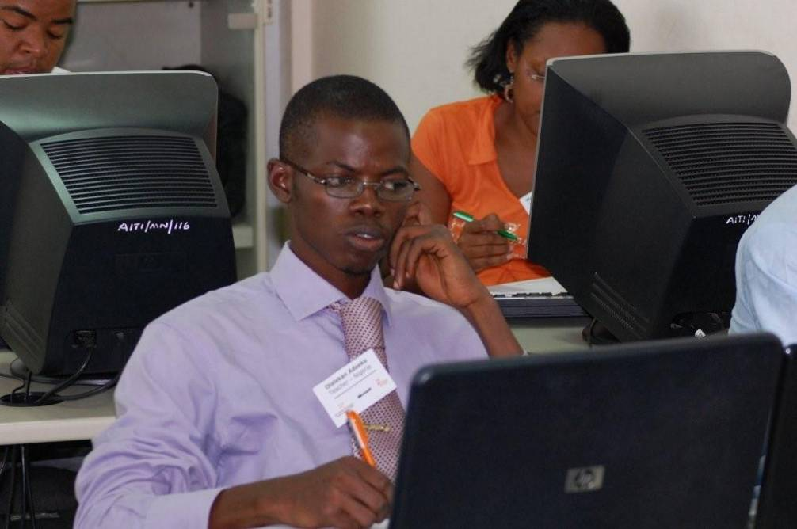
Two sessions were held in the computer lab to give teachers an opportunity to have some hands-on experience. Abdullah Hakeem Ajijola and Tarimin Kewa’s session on “Microsoft Tools that enhance learning and teaching” showed teachers the benefits of having a live ID and how to protect their learners online. Harry Tetteh’s session on “Collaboration and its power” provided an inspirational account of how this Ghanaian teacher from a deep rural area had participated in and won the ThinkQuest competition.
Many of the participants at the Forum were Microsoft Partners in Learning trainers, or they had undergone PiL training. Debbie Dowie’s presentation gave teachers an opportunity to share ideas and experiences for “Getting others to use ICT”. Although the teachers at the Forum had already proven that they were dedicated teachers, Natalie Whittaker’s session on “Getting Motivated” gave some additional strategies for keeping their spirits up. Angela Schaerer’s lesson review workshop gave participants an opportunity to reflect on what makes a lesson innovative, and to consider some of the projects on display through this lens.
The participants all agreed that they had learnt something from the event and that they had come away with a range of ideas to help them to continue to teach in an innovative way. These quotations from participants show that the objective of sharing knowledge at the forum was achieved:
“The forum is a very great event and brings about a lot of ideas and knowledge about how to be an effective teacher.”
“On the whole it has been a fruitful experience. I have gained insights into the integration of ICT in different subjects”

“Conference/ forum is very good and quite educative.”

Conclusion
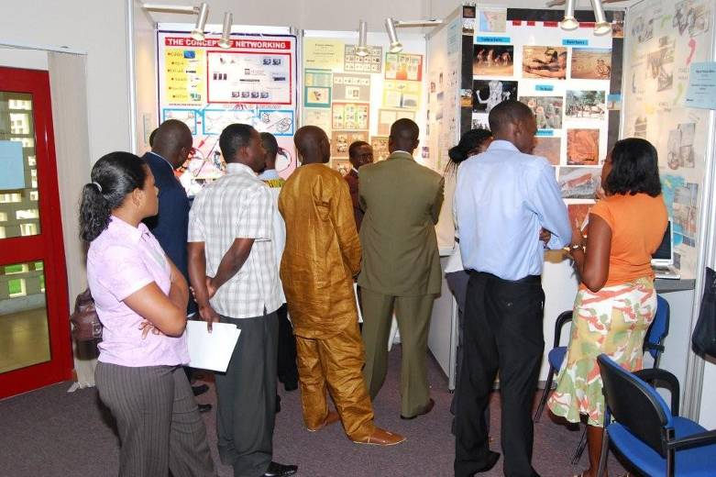
On the whole the first Pan African Innovative Teachers Forum was a great success with all teachers reporting that it was a worthwhile event that equipped them with a range of ideas for innovative teaching. These sentiments are echoed in the following responses from teachers:
“The management done for our stay in Ghana was just great. Everything has been done in a professional and pleasant way. The sharing that took place during the forum was very interesting and inspiring for new ideas in teaching. I really thank Microsoft for this incredible initiative at African level. Wish to participate next year.”

“A big thank you to Microsoft for the opportunity offered to teachers to come together and share ideas”

“I am impressed by the ITF and look forward to attending next year’s edition. Kudos to the funding partners and organisers for the conference.”

SchoolNet SA was proud to be a part of this initiative and we hope that we may have the opportunity to help facilitate future Microsoft Pan African Innovative Teachers Forums.
Megan Rademeyer
SchoolNet SA Programmes Manager
June - 2008

