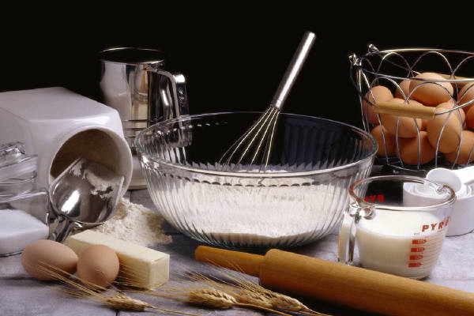
Family Recipe
From the kitchen of:
Ingredients:
Directions:
Tradition, memory, or history related to this recipe:

