Frog Life Cycle Diagram Puzzle

Cut out the pieces on the dotted lines. Mix up the pieces. Then match the labels with the pictures and put them in the correct order.

 |  | 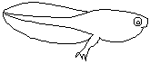 | 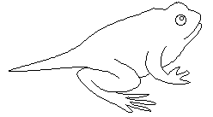 | 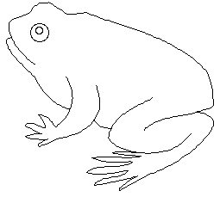
Stage 1—Egg  Tiny frog eggs are laid in masses in the water by a female frog. The eggs hatch into tadpoles. | Stage 2—Tadpole  Tadpoles are also called pollywogs. This stage hatches from the egg. The tadpole spends its time swimming in the water, eating, and growing. Tadpoles breathe using gills, and they have tails. | Stage 3—Tadpole with Legs  In this stage, the tadpole sprouts legs (and then arms), has a longer body, and has a more distinct head. It still breathes using gills and has a tail. | Stage 4—Froglet  In this stage, the almost mature frog breathes with lungs and still has some of its tail. | Stage 5—Adult Frog  The adult frog breathes with lungs and has no tail because it has been absorbed by the body.

Copyright ©2001 EnchantedLearning.com
Permission to reproduce granted for noncommercial use.

