Cell Discoveries
Biology
The Big Debate, Stem Cell Research
NIH Publishes Final Guidelines for Stem Cell Research
Volume 1, Issue 1
July 11, 2005

The National Institutes of Health (NIH) today put out its final guidelines for research involving human pluripotent stem cells. The guidelines describe how this research should be done so all ethical and legal concerns are considered.
Research using human pluripotent stem cells may help scientists grow cells and tissue that could be used for transplantation to treat many diseases.
Additionally, this research promises new treatments and possible cures for diseases and injuries, such as Parkinson's disease, diabetes, heart disease, multiple sclerosis, burns and spinal cord injuries. The NIH believes the possible medical benefits of human stem cell technology are
worth pursuing and can be studied while staying within ethical standards.

www.nih.gov/news/pr/aug2000/od-23.htm

Inside this issue:
Stem Cells and NIH 1

New Cancer Research 1

Cell Communication 2

Student Commentary 2

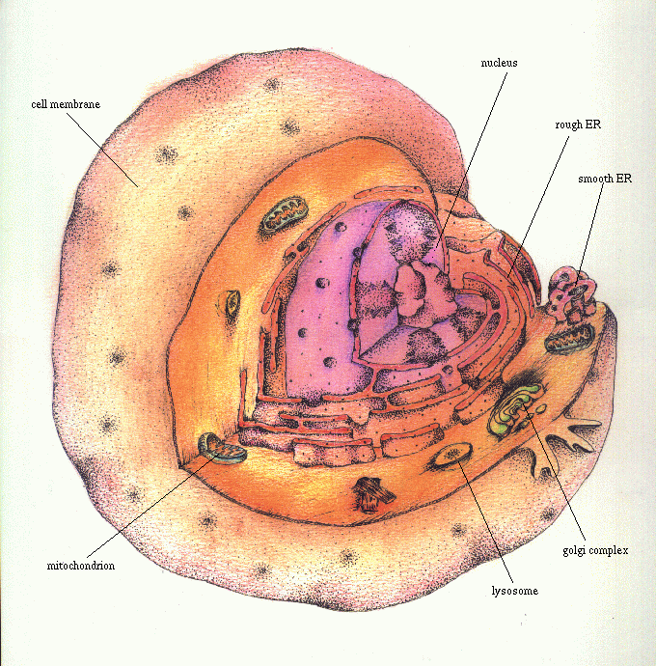
Important Terms
Leukemia—a cancer of the blood-forming tissue. Leukemic cells look different than normal cells and do not function properly.
Stem cells—cells that have the ability to divide for indefinite periods in culture and to give rise to specialized cells.
Pluripotent—capable of giving rise to most tissues of an organism.

Myelogenous—relating to abnormal growth of immature white blood cells known as myelocytes, which interfere with normal bone cell function.

The nucleus contains the genetic material and controls the expression of genes that cause leukemia. Stem research can be used to remove or alter this gene preventing leukemia.

Special points of interest:
- The debate continues...should stem cell research be legal and federally funded?
- Can cell protein be changed? New leukemia treatment says it can.
- Talking Cells? Chemical Communication? How do cells interact?

FDA Approves New Leukemia Drug,
Molecular Targeting Looks Promising

The U.S. Food and Drug Administration (FDA) announced today its approval of the drug Gleevec as an oral treatment for the cancer called chronic myelogenous leukemia (CML).
Gleevec is the first drug that directly turns off the signal of a protein known to cause a cancer. Other molecule-targeting drugs that have been approved by the FDA interfere
with proteins that

appear with other cancers, but not the proteins that directly cause the disease.

NCI Press Office: http://newscenter.cancer.gov/pressreleases/gleevecpressrelease.html

Cell Communication
brain cells, regulating many bodily functions. Those messages result in the right responses only because they are transmitted precisely and deeply into a recipient cell.
The exact molecules are able to carry out the directives because the connection from cell to cell is so precise.
Page 5
Volume 1, Issue 1

Cells can communicate by using cytoplasmic projections (appendages that stretch off from the cell membrane).
The body functions properly only because cells communicate with each other constantly. Pancreatic cells, for instance, release insulin to tell muscle cells to take up sugar from the blood for energy. Cells of the immune system instruct their white blood cell cousins to attack invaders, and cells of the nervous system rapidly fire messages to and from
Bone marrow,
the soft, sponge-
like material
found
inside
bones
contains
immature cells known as hematopoietic or blood-forming stem cells. These hematopoietic cells, which are also found in the bloodstream and umbilical cords, can be used in transplants (BMT) to restore stem cells that
Student Commentary
Stem Cell Research
Through reading some of the news and opinion articles that deal with stem cell research, I have come to the conclusion that SSR is generally beneficial to medicine and society at large. It could help to cure leukemia.
I feel that the use of embryos for this research is acceptable and should continue. I do not believe that a bundle of embryo cells is a human life, because it could not live outside the body of the mother at this stage. In fact, the frozen embryos available for use in stem cell research are ones that have been donated by couples and would otherwise be discarded. No life that would have existed is being stopped prematurely.
I know the president wants to limit stem cell research to the 60 already-existing stem cell lines. This set is not diverse enough. Currently there are 100,000 frozen embryos (representing at least 25,000 stem cell lines) that have been donated for research. The government should let these be used by medical researchers as they seek new cures for diseases that prematurely shorten life, such as leukemia.
I understand that there is still much to be discovered in the area of cell research, and I think that we have come to a crossroads when it comes to understanding what we are capable of in this area.

CNN.com: www.cnn.com/2001/ALLPOLITICS/08/09/stem.cell.bush

National Institutes of Health: www.nih.gov/news/stemcell/082701list.htm

ReligiousTolerance.org: www.religioustolerance.org/res_stem.htm

Ethics Institute, Dartmouth College: www.dartmouth.edu/artsci/ethics-inst/stemcell.html
have been destroyed by chemotherapy. One reason BMT and PBSCT are used in cancer treatment (particularly leukemia) is to make it possible for patients to receive very high doses of chemotherapy and/or radiation therapy. This allows them to combat the disease better.

Bone Marrow Transplants Help
Cancer Patients

