Student design teams create publications for a hotel client.
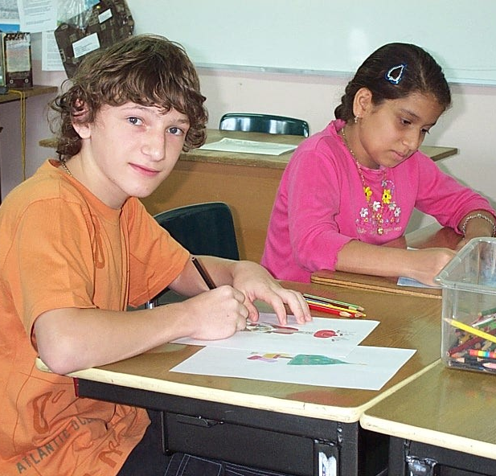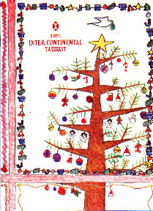
The team draws holiday art, which is scanned and added to the brochure.

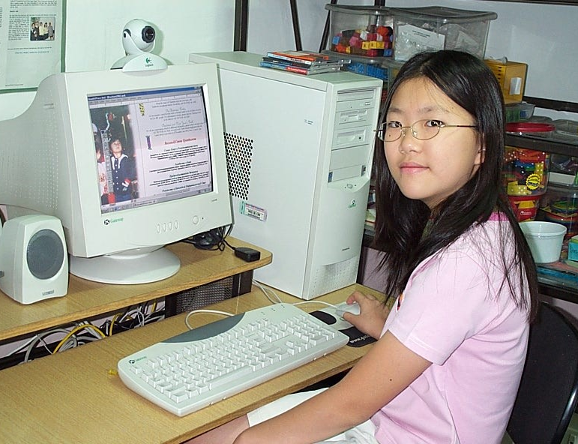  They learn to use desktop publishing software. | 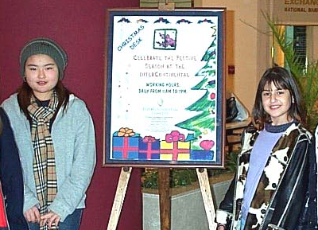  A poster shows event information.

