
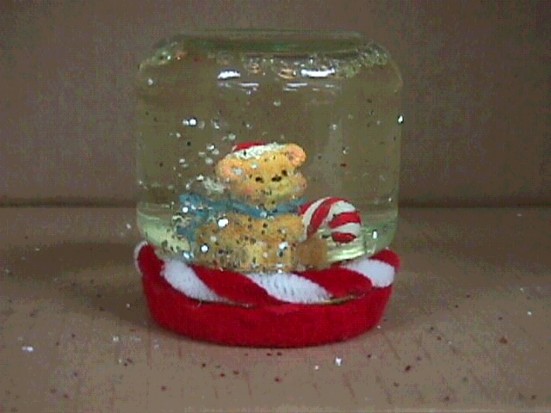
Snow Globes. Etc.
The purpose of The Recycling Craft Faire is to foster a spirit of fair business practices and encourage students to recycle. Students research on the Internet to find products that they can make using recyclable items. Then they mass-produce the products, design and print a brochure using persuasive advertising techniques, and price the items to sell. The Faire is held the last Wednesday before Christmas break. Students display their products with attractively made signs. Teachers, parents and classmates may shop and purchase items during three class periods. All proceeds go to a charity selected by the students. Past recipients include: TugBoat Island upkeep fund, The American Cancer Society and local children in need of costly medical attention.

"Our globes will turn your world upside down."
Port Neches Middle School
6th Grade Recycling Craft Faire
Interdisciplinary Studies Class
6th Grade
Port Neches Middle School
Port Neches, TX
Why We Began the Craft Faire.
Picture found: www.afandpa.org/kids_educators/index.html
What are the facts?
- Many recycled materials are still thrown away every day
- 73% of glass containers
- 77% of magazines
- 66% of plastic bottles
- 45% of newspapers
- The national recycling rate is 28%. The EPA has set a goal of 35%.
- It takes 95% less energy to recycle aluminum than to make it from raw materials.
- 94% of the natural resources that America uses are nonrenewable.
- Recycling saves 11 times the amount of energy generated by methane recovery at a landfill.
© National Recycling Coalition—www.nrc-recycle.org

www.graphics-by-celeste.com

You need the following materials to make your own beautiful snow globe.
- Small baby food jar with lid
- Water with several drops of glycerin
- Glitter and/or confetti
- Hot glue gun
- Small plastic figures (animals, snowmen, houses, etc.)
- Fast drying craft glue (non-water based)
Remove the label and clean the jar and lid thoroughly. Turn lid upside down and use hot glue gun to attach figurines to inside of lid. Allow the glue to cool and set completely. Turn jar upright and add glitter or confetti sparingly. Next, add water with glycerin to within an 1/8 inch from top. Carefully put a thin line of glue on inside edge of lid. Screw lid onto jar and allow to dry before shaking. Presto!! You have made an inexpensive snow globe from recy-cled materials.
- Reuse jars, boxes, and other containers.
- Maintain and repair durable products.
- Buy reusable alkaline batteries (with no toxic cadmium or mercury).
- Bring your own shopping bags to the store, or reuse theirs.
- Reuse grass clippings as fertilizer by leaving them on the lawn (using a mulching mower) or by adding them to your compost pile.
- Sell or donate things you no longer need, instead of throwing them out.
Information found at: www.environmentaldefense.org/pubs/Brochures/BuySmart/b_anounce.html
© 2000 Environmental Defense; reprinted by permission. For information, write Environmental Defense, 257 Park Ave. South, New York, NY 10010; or e-mail members@environmentaldefense.org
Web site: www.environmentaldefense.org

You Can Make a Difference.
For every snow globe you purchase, you have saved a valuable resource, silica, a mineral from the earth. You have also kept trash out of the landfills. All of the proceeds from the sale of the globes will go directly to a worthy charity. Not only are you conserving our resources and valuable land space but you have made a donation to a worthwhile cause. You can and will make a difference!
A Waste-Prevention Shopping List
When you reduce, you literally buy less of the things you don't need, like excess packaging. Think Reduce:
- Choose products with the least packaging, and thank store managers for stocking them.
- Buy whole fruits and vegetables to avoid the unnecessary trays and wraps.
- Buy the large or economy size (less packaging per pound of product).
- When you have just an item or two, say, "No bag, thanks."
- Ask yourself a few questions before you buy something: "Do I really need it? Could I borrow one from a friend or neighbor? Do I have something already that can do the same job?”
When you reuse, you literally buy less of the things you don't need, like excess packaging. Think Reuse:
- Use durable items such as reusable cups, plates, utensils, cloth napkins, sponges, and dishcloths.
- Look for products that are available in refillable packages.
Interdisciplinary Studies Class
6th Grade
Port Neches Middle School
Port Neches, TX
"Our globes will turn your world upside down."
Step-by-Step Instructions

