Don’t Trash the Earth Spreadsheet Instructions

Step 1: Collect Data
Collect data for the trash unit (school waste management, family garbage production, cost analysis, and so forth).

Step 2: Create a Spreadsheet
Open a worksheet in a spreadsheet application. In cell A1, type the title of your study (for example, type How much garbage does my family of four produce?). To make your title go across several columns, highlight the cells you want it to cover, select the Format menu, click Cells, and click the Alignment tab. In the Text control section, click Merge cells, and click OK. You can now center your title and change the font size and style. You may even change the background fill color.

In row 3, beginning in cell A3, type column and row headings to label the items that you measured or counted (see the following example). Next, enter your data in columns B or columns B and C.

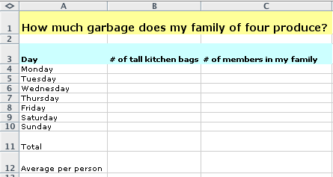

Step 3: Create a Chart or Graph
Highlight all of the cells that you want to represent graphically. Click Chart from the Insert menu. Choose the chart type that you think best represents your data, click the Next button, and then follow the specific directions for the chart or graph. Add titles for the chart and its axes if appropriate. Click the Gridlines tab and experiment with gridline options if gridlines apply to your type of chart or graph. Choose gridlines that make understanding your data easier. Click the Legend tab, choose a location for the legend, and then click Next. Place your chart or graph as an object on the original worksheet, so that you can see the worksheet entries as you examine the object, or place your chart or graph on a separate sheet of your worksheet and label it (see the following example, which represents the spreadsheet data in the next sample).

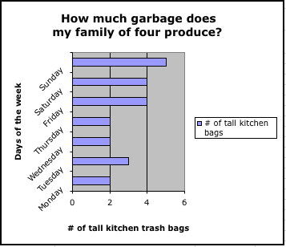

Explore several options of charts to see which one best represents your data! Or choose several different types of questions from the survey to represent with different charts.

Step 4: Create a Formula Using the Formula Bar

To create a formula for automatic calculation, click the cell that you want to contain the calculation. Type an equal sign (=) in the Formula Bar. Determine the operation or formula you want to calculate. For example, to find the average # of trash bags per family member, you would divide the total number of tall kitchen bags divided by the number of people in your family. Your formula might look similar to =B11/C11.

Step 5: Create a Formula Using the Insert Function Dialog Box
To create a formula using the Insert Function dialog box, click the cell that you want to contain the function. Choose the Insert menu, and click Function. The Insert Function dialog box opens. Choose a function (many functions are available—click each function to see a short description). Click OK. In the Number 1 text box, enter the cells you want the function to include. For instance, in this example, type B4:B10. Click OK. Your data is calculated and shown in the cell you selected.
