Extra Bonus
.privatefuelstorage.com/. ../pelletinhand.jpg

Works Cited

Carbon, M. W. (1997). Nuclear Power: Villain or Victim. Madison. WI: Pebble Beach Publishers.

Ewing, R. A. (2004). Hydrogen: Hot Stuff, Cool Science. Masonville, KY: PixyJack Press

Gabbard, A. (2004, May). Coal Combustion. Retrieved June 15, 2006, from www.ornl.gov/info/ornlreview/rev26-34/text/colmain.html

Griscom, A. (2002, June). Alternative Energy Crisis. Retrieved June 20, 2006, from www.grist.org/news/powers/2002/06/11/alternative

Walter, A. E. (1995). America the Powerless: Facing our Nuclear Energy Dilemma. Madison, WI: Cogito Books.

The development of hydrogen fuel cells has been delayed mostly because the energy required to separate hydrogen from oxygen is immense. Nuclear energy is the answer to that problem. If nuclear energy can be rid of its shackles, then it is the most efficient source used to complete this new technology. Hydrogen fueled cars alone would drastically cut the emissions of carbon dioxide in our atmosphere.
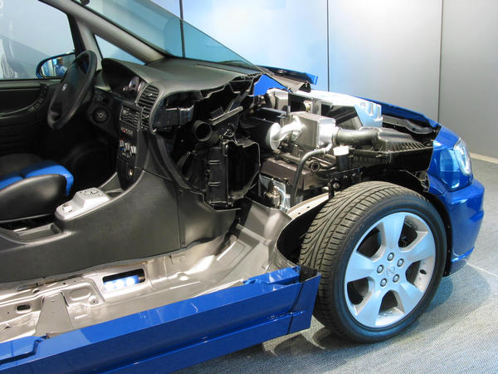

Nuclear Energy
Nuclear Energy

waste not, want not
The Choice is Clear:
3 barrels of oil, 1 ton
of coal, 17,000ft³ of propane, or this...
http://auto.pege.org/2004-opel-zafira/motorraum.jpg
One Uranium Fuel Pellet

What is the New Nuclear Energy?
- The release of nuclear components from coal combustion far exceeds the entire U.S. consumption of nuclear fuels. The same conclusion applies for worldwide nuclear fuel and coal combustion.
- Large quantities of uranium and thorium and other radioactive species in coal ash are not being treated as radioactive waste.
- Nuclear waste products from coal combustion are allowed to be dispersed throughout the biosphere in an unregulated manner.

Coal is still the main source (50%) for energy in the United States—WHY?

Benefits

Uranium enrichment in the United States currently generates about 14 million tons of CO² annually but U.S. nuclear power plants prevent the emission of 164 million tons of carbon, 5.1 million tons of sulfur dioxide, and 2.4 million tons of nitrogen oxides.

Nuclear plants do not cause silting of rivers.

Is the cheapest energy once power plants are built.

Current nuclear reactors return around 40–60 times the invested energy when using life cycle analysis. This is better than coal, natural gas, and current renewables except hydropower.

Radiation from nuclear plants has not caused a single known death worldwide except at Chernobyl (less than 50) and those would have been prevented if it was an American-designed plant.

Obstacles
- Fear has been the single largest obstacle to the widespread use of nuclear power.
- If radiation emissions from coal plants were regulated like nuclear plants, their capital and operating costs would increase, making coal-fired power less economically competitive.

Coal vs. Nuclear
- Coal combustion is more hazardous to health than nuclear power; it adds to the background radiation burden even more than does nuclear power.
- The amount of uranium-235 alone dispersed by coal combustion is the equivalent of dozens of nuclear reactor fuel loadings.
- Americans living near coal-fired power plants are exposed to higher radiation doses than those living near nuclear power plants that meet government regulations.
- The population effective dose equivalent from coal plants is 100 times that from nuclear plants.
Read the facts, dispel the myths, and exit the fear zone
http://www.cavendishscience.org/bks/nuc/pebble.gif
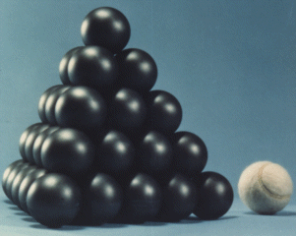
www.cavendishscience.org
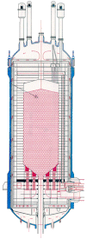
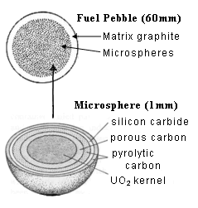
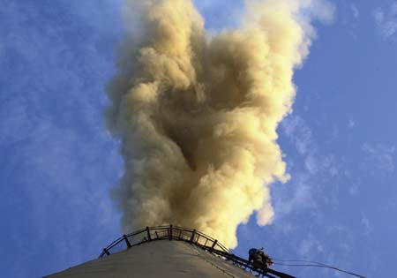
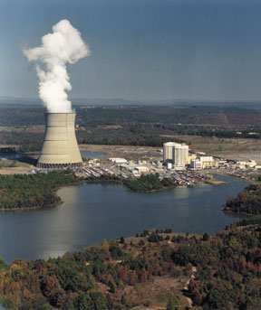
Nuclear Energy

One pound of coal produces two pounds carbon dioxide. Nuclear fission can never produce more waste than the original fuel in weight or volume. The new helium gas-cooled Pebble-Bed Modular Reactors are a modern marvel. Nuclear rods are replaced with silicon balls that contain enriched uranium. 25% of the balls are made of solid graphite to slow down the U-235 fission process. The balls can be cycled through the reactor rather than shut down to refuel as in the old design. Helium gas is used for cooling instead of water which is an advantage since helium will not bond with anything else so it won’t become radioactive and is also non-corrosive. This makes it perfect to cool the reactor and turn the turbine. The reactor is passively safe which means the reaction slows as the temperature rises. The laws of physics dictate that the reaction has to stop before the reactor reaches a melting point. The spent fuel (waste) is contained in the balls by a layer of silicon carbide to isolate the radioactive waste for hundreds of millennia.

For more information

on weapon proliferation, disposal, risks, and costs associated with nuclear energy
visit our Web site
www.thechoiceisclear.com
www.eskom.co.za/nuclear_energy/pebble_bed/image1_2.gif
www.algor.com/news_pub/cust_app/enterg/images/fac1.jpg
Nuclear plant emit no particulates (see study and experiment on our Web site)
Coal emits sulfur dioxide (acid rain), nitrogen oxides (harmful to health), carbon dioxide (green house effect), and at least two sources of radiation: thorium and uranium.

