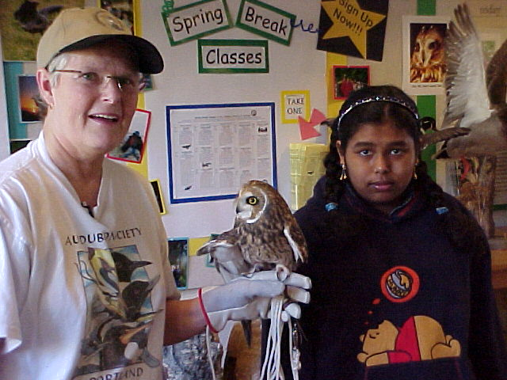
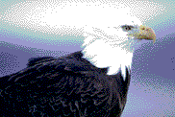
Portland Public Schools
Inside this issue:
What’s killing our birds and Wildlife?
Portland Audubon’s wildlife Care Center:
a place for Injured Wildlife
Volume
Newsletter Date
Special points of interest:
- Urban Eco System Program is a Title 11 Grant that helps students take classroom curriculum and apply it to the real world.
- Read in this paper how these Urban Eco System students mixed, math, science and public speaking to help urban wildlife.
Gms news express
If you find injured wildlife call:

503:2926855: Ask for the Wildlife Care Center

5141 NW Cornell Road, Portland, Oregon, 97210
Cats Injure Birds 2

Let’s go Fishing: 2

Study of Bird Anatomy 2

A small brown bird, her wing broken, was brought into the Portland Audubon’s Wildlife Care Center on Dec. 6th 2000. Al, a student from George Middle School, rescued this bird from a cat. The center took data about this bird, a winter wren, and proceeded to set the wing, and stop the bleeding. Three weeks later, the small wren was healed, and released back where it was found. This bird was lucky. Many small passerines have great difficulty recovering from this kind of injury.
George Middle School students from Ms. Gonzales’s class teamed up with Portland Audubon’s Wildlife Care Center to help understand what is killing our wildlife. George students analyzed the center’s data to determine the major causes of injuries to our urban wildlife. This work is the result of a ear-long study, as part of the Urban Eco System Project, a federal Title 11 grant to apply student class work to urban issues. “Students combined studies in animal adaptations, graph interpretation, and applied technology with a real-world community issue,” said Ginny Rosenberg Stern, Urban Eco system Coordinator. The results of this study follows.

What caused the injury?
How many birds hurt ?
Cat 2,970
Human interference 2,111
Hit by car 1,829

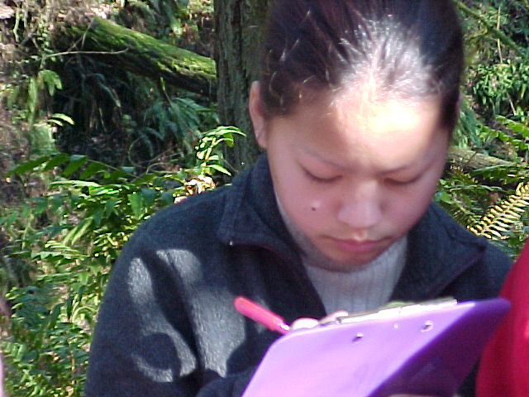
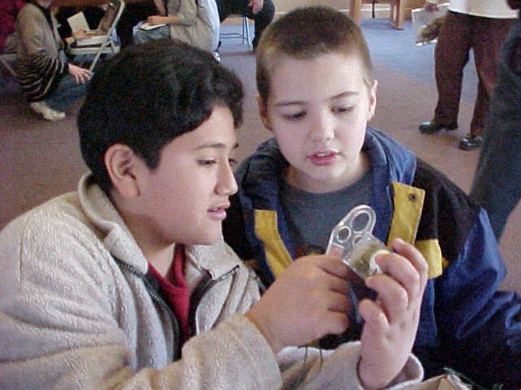
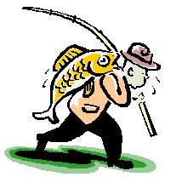
Caption describing picture or graphic.
Students looking closely at bird anatomy during a recent field-trip to the Audubon Education Center.
George Middle School students completed a five-year study to determine some of the major causes of injury to our urban wildlife populations. Working with the Audubon Wildlife Care Center, students analyzed the centers
data and determined that people pets, specifically cats, are a major cause of injury to wild birds.
Students traveled to various public forums, including neighborhood association meetings, library facility night and a board meeting at the Oregon Humane Society to present the results of their study. Once the results were presented, students organized the audience into groups and helped to brainstorm ways in which people can help birds be less threatened by domestic cats.
Here are some of the results of the brainstorming session:

How to prevent cats from injuring birds:
- Tie 2 bells around the cats neck.
- Watch your cat when you let it out. Don’t let your cat wander around outside by itself.
- Keep your cat indoors with a kitty litter box. This is especially important in the spring, when baby birds are just out of the nest.
- Spay or neuter your cat.
its anatomy, we can better understand what makes them easy targets for the different types of urban injuries that they get; like from cats, or hitting windows.” Said John, an 8th grade participant.
George Middle School students studied the anatomy of a bird with the help of Portland Audubon Society. Each student got to look at a bird skeleton, inspect samples of wings, and examine owl pellets. Students used worksheets to uncover the science being the wonder of bird adaptations.
“If we understand how a bird is adaptive, and understand
Page 2
Let’s Go Fishing…. But take our garbage with us to save wildlife
Cats injured 2,970 wild birds in the last 5 years. What can be done?

George Students Study Bird Anatomy
every where.” said Sue, a 6th grader from the school. And to think that all this garbage could hurt or even kill a duck or a great blue heron…”
Students made a list of things for all of us to pack out when we go fishing. Next time, lend a hand, bring a garbage bag with you, and educate people
along the shoreline. Fishing equipment that can be hazardous to wildlife:

Fishing line: can get wrapped around the neck of a bird and cut its skin
Styrofoam cups that your worms came in: Birds can eat it. It doesn’t digest well and fills their stomachs
Students from George Middle School got a list of the types of garbage that fishermen leave behind that can hurt or kill wildlife. Students then went out to a favorite fishing spot in their neighborhood to collect garbage that is hazardous to birds and other wildlife. “I was surprised to see how much garbage was left

“Before the trip to the bird wildlife care center, I never knew that the things that I did in my every day life could hurt or injure a bird. Next time I go fishing I will pick up the fishing line and fishing hooks that can get caught around a birds neck.” Sam, GMS student

if
Volume 1, Issue 1

