Label the Fruit
Name : _____________________________

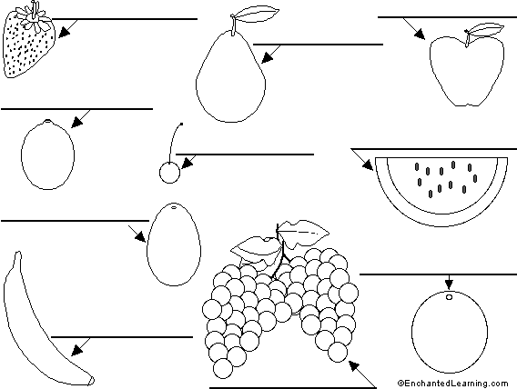
apple  avocado  banana | cherry  grapes  lemon | orange  pear  strawberry  watermelon
TASK

Copy the words under the correct picture.

EVALUATION

8 to 10 Correct - Excellent (2)

4 to 7 Correct - Good (1)

0 to 3 Correct - Need to try harder (0)

