Vintery, Mintery, Cutery, Corn | 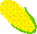

Vintery, mintery, cutery, corn,

Apple seed and apple thorn;

Wire, briar, limber lock,

Three geese 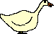in a flock.

One flew east, 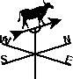

And one flew west,

And one flew over,

The cuckoo's 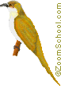nest.
----THE END----

