Learner Support Material: Road to Democracy

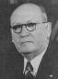
Fill in the flow chart below. Delete the question and rewrite it as an answer to create a chronological timeline of the Apartheid era (for example the first box requires you to write ‘The NP came to power in 1948’. This exercise will help you when you construct your newsletter, presentation and web site later in this unit.)

What year did the National Party come to power in South Africa?

1

2
The Population Registration Act was passed in …
The leader of the NP was ….
The racial policy they wanted to implement became known as …
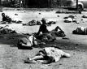
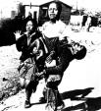
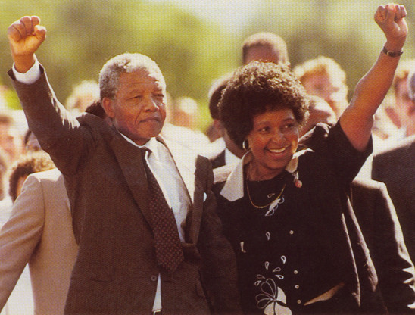
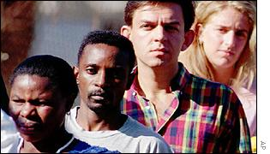

When did this man become Prime Minister? Name him.
3
The Group Areas Act was passed in …

4
3 laws passed in 1953 included:
a] ………………
b] ……………..
c] ……….…….

5
6

When was theSharpeville massacre?

7

When were the Soweto Student Riots?

9
When were the first democratic elections in South Africa?

8

When was Nelson Mandela Released from Victor Verster Prison?

